PACKAGE :PyMuPDF

ERRORS I GOT WHILE DOING THIS:

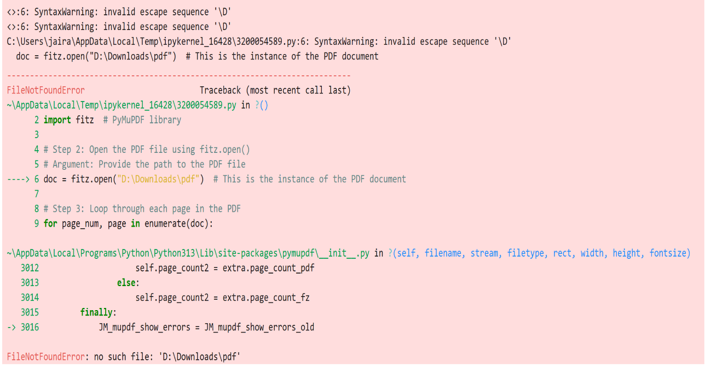1.First I installed and while creating the instance I entered my pdf path wrong.

How I rectified: I went to file manager and entered the correct path of the pdf

2.After correcting the error I got the output .